Using the project database create the following TQL objects.  For each question, submit a screenshot of the the actual code, as well as the code being tested.

1. Create Insert/Update Triggers on the Customers and Employees tables that will uppercase all the varchar fields

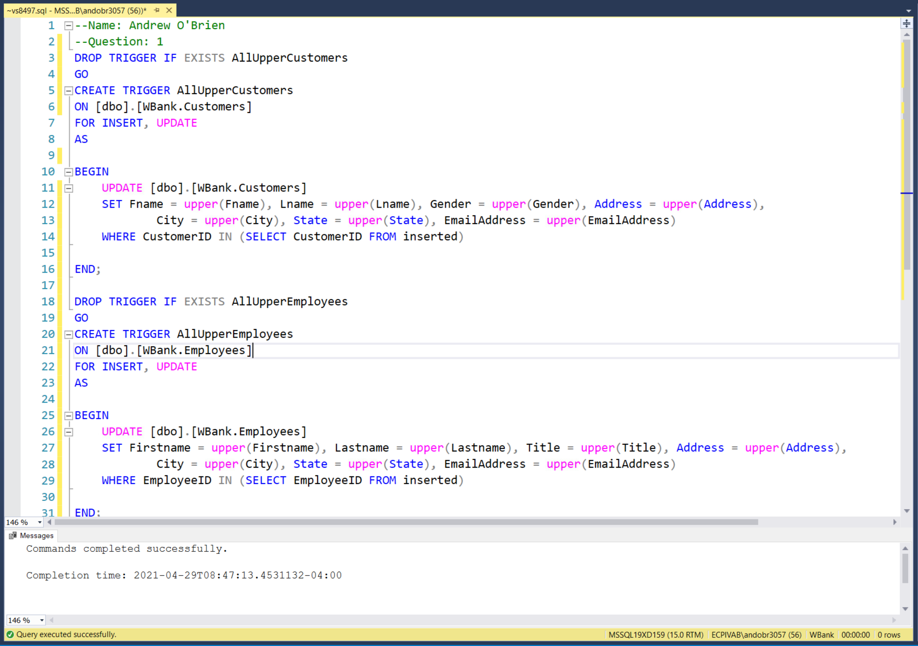

1. Create Insert/Update Triggers on the deposits and withdrawal tables that rollbacks a transaction that has a negative amount.

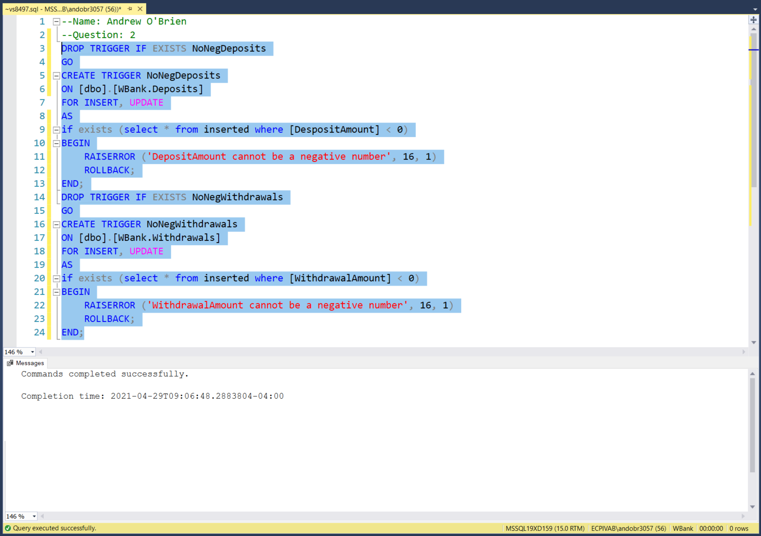

3)Create a function, called fn_balance, that takes in a customerID as a parameter, and then returns the total balance available for that customer. This function should return a money parameter that shows the customer's current balance.

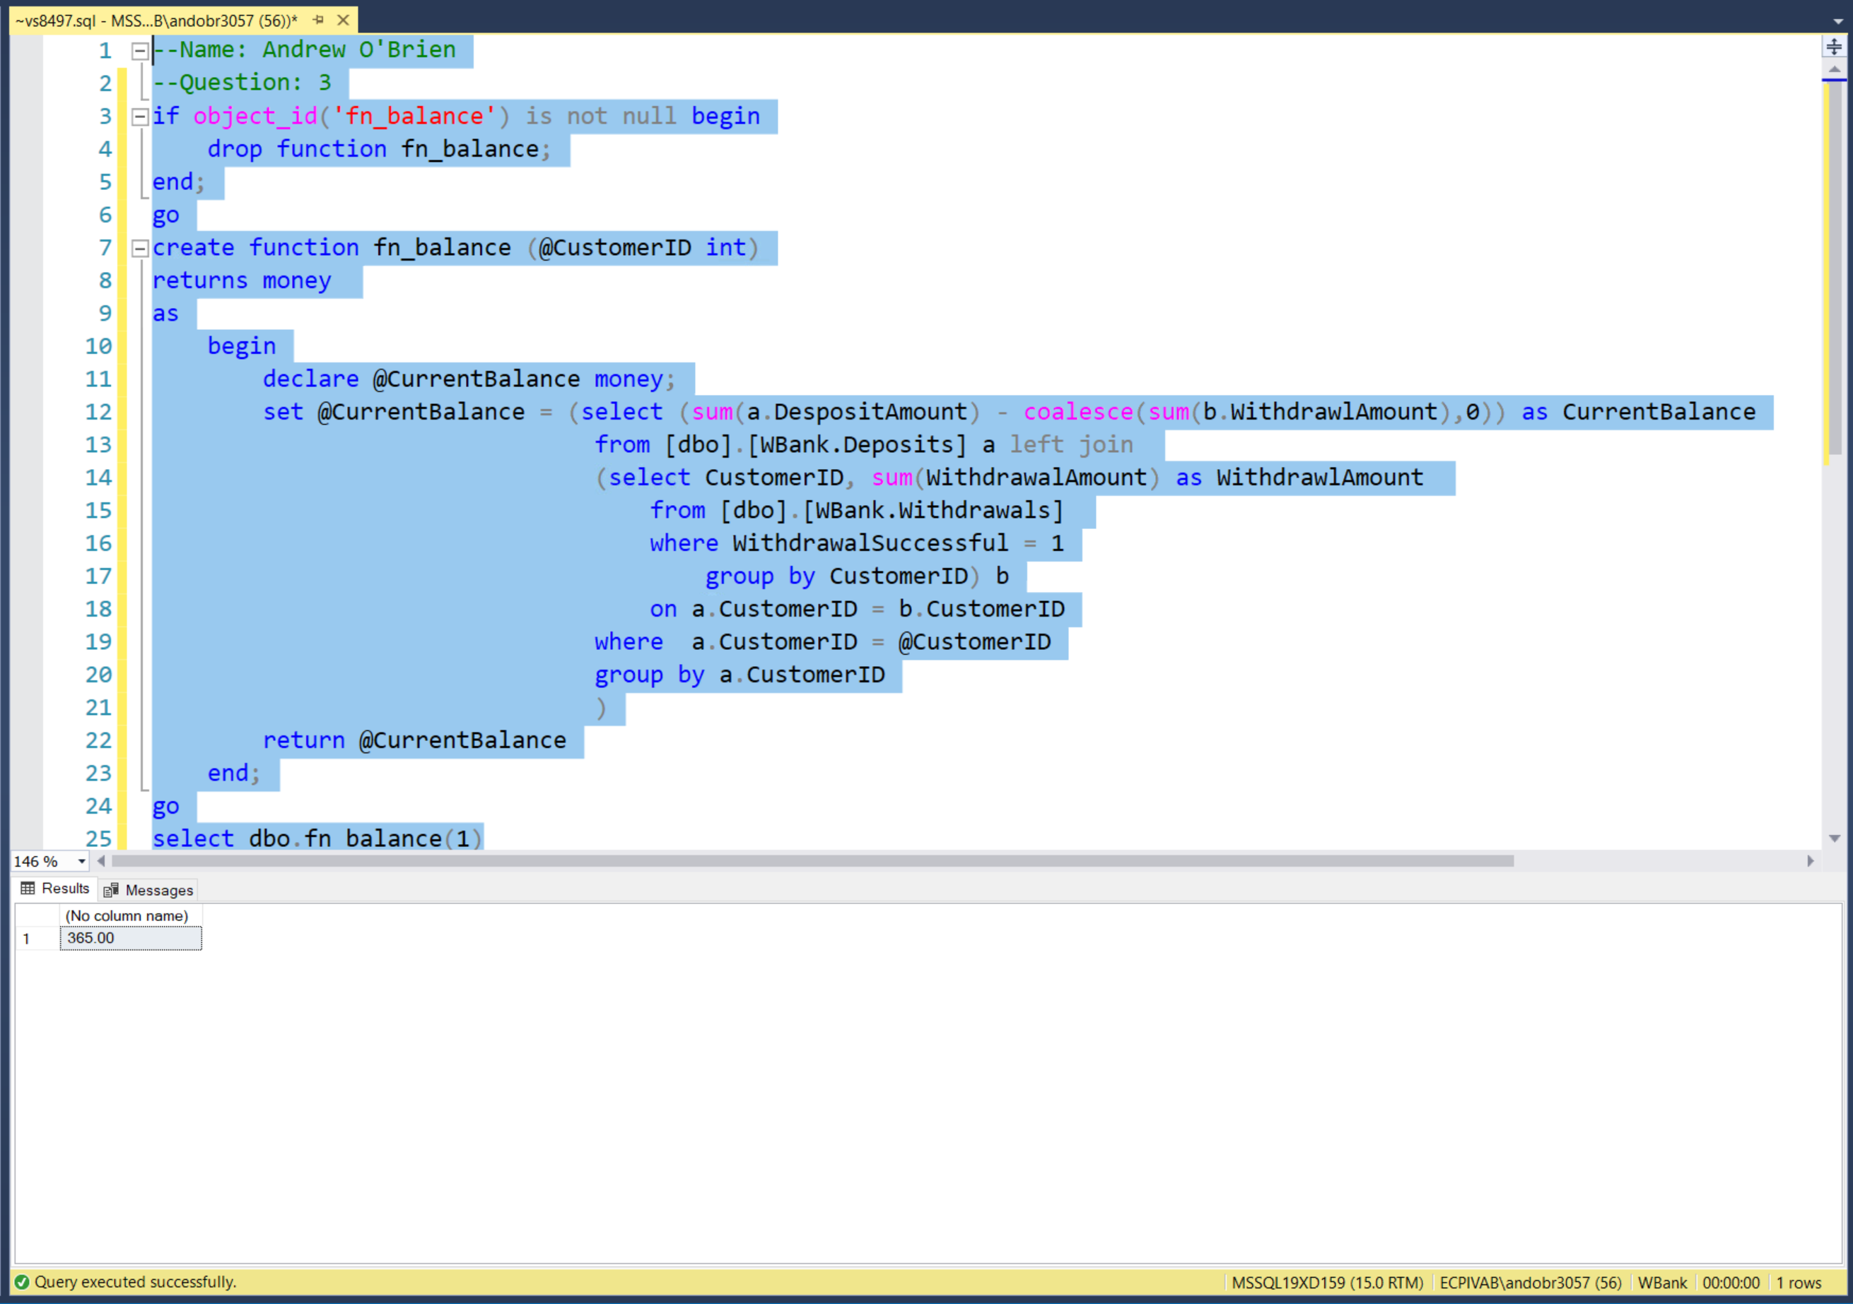

1. Create a view, called  vw_Customers, that shows all the customers (Full name in one column, Account Number, and Type of Account they have, and their current balance). Have the columns returned be called full_name, account_number,  type_of_account, balance (Hint, you should use your Function created in question 3 to help with this).

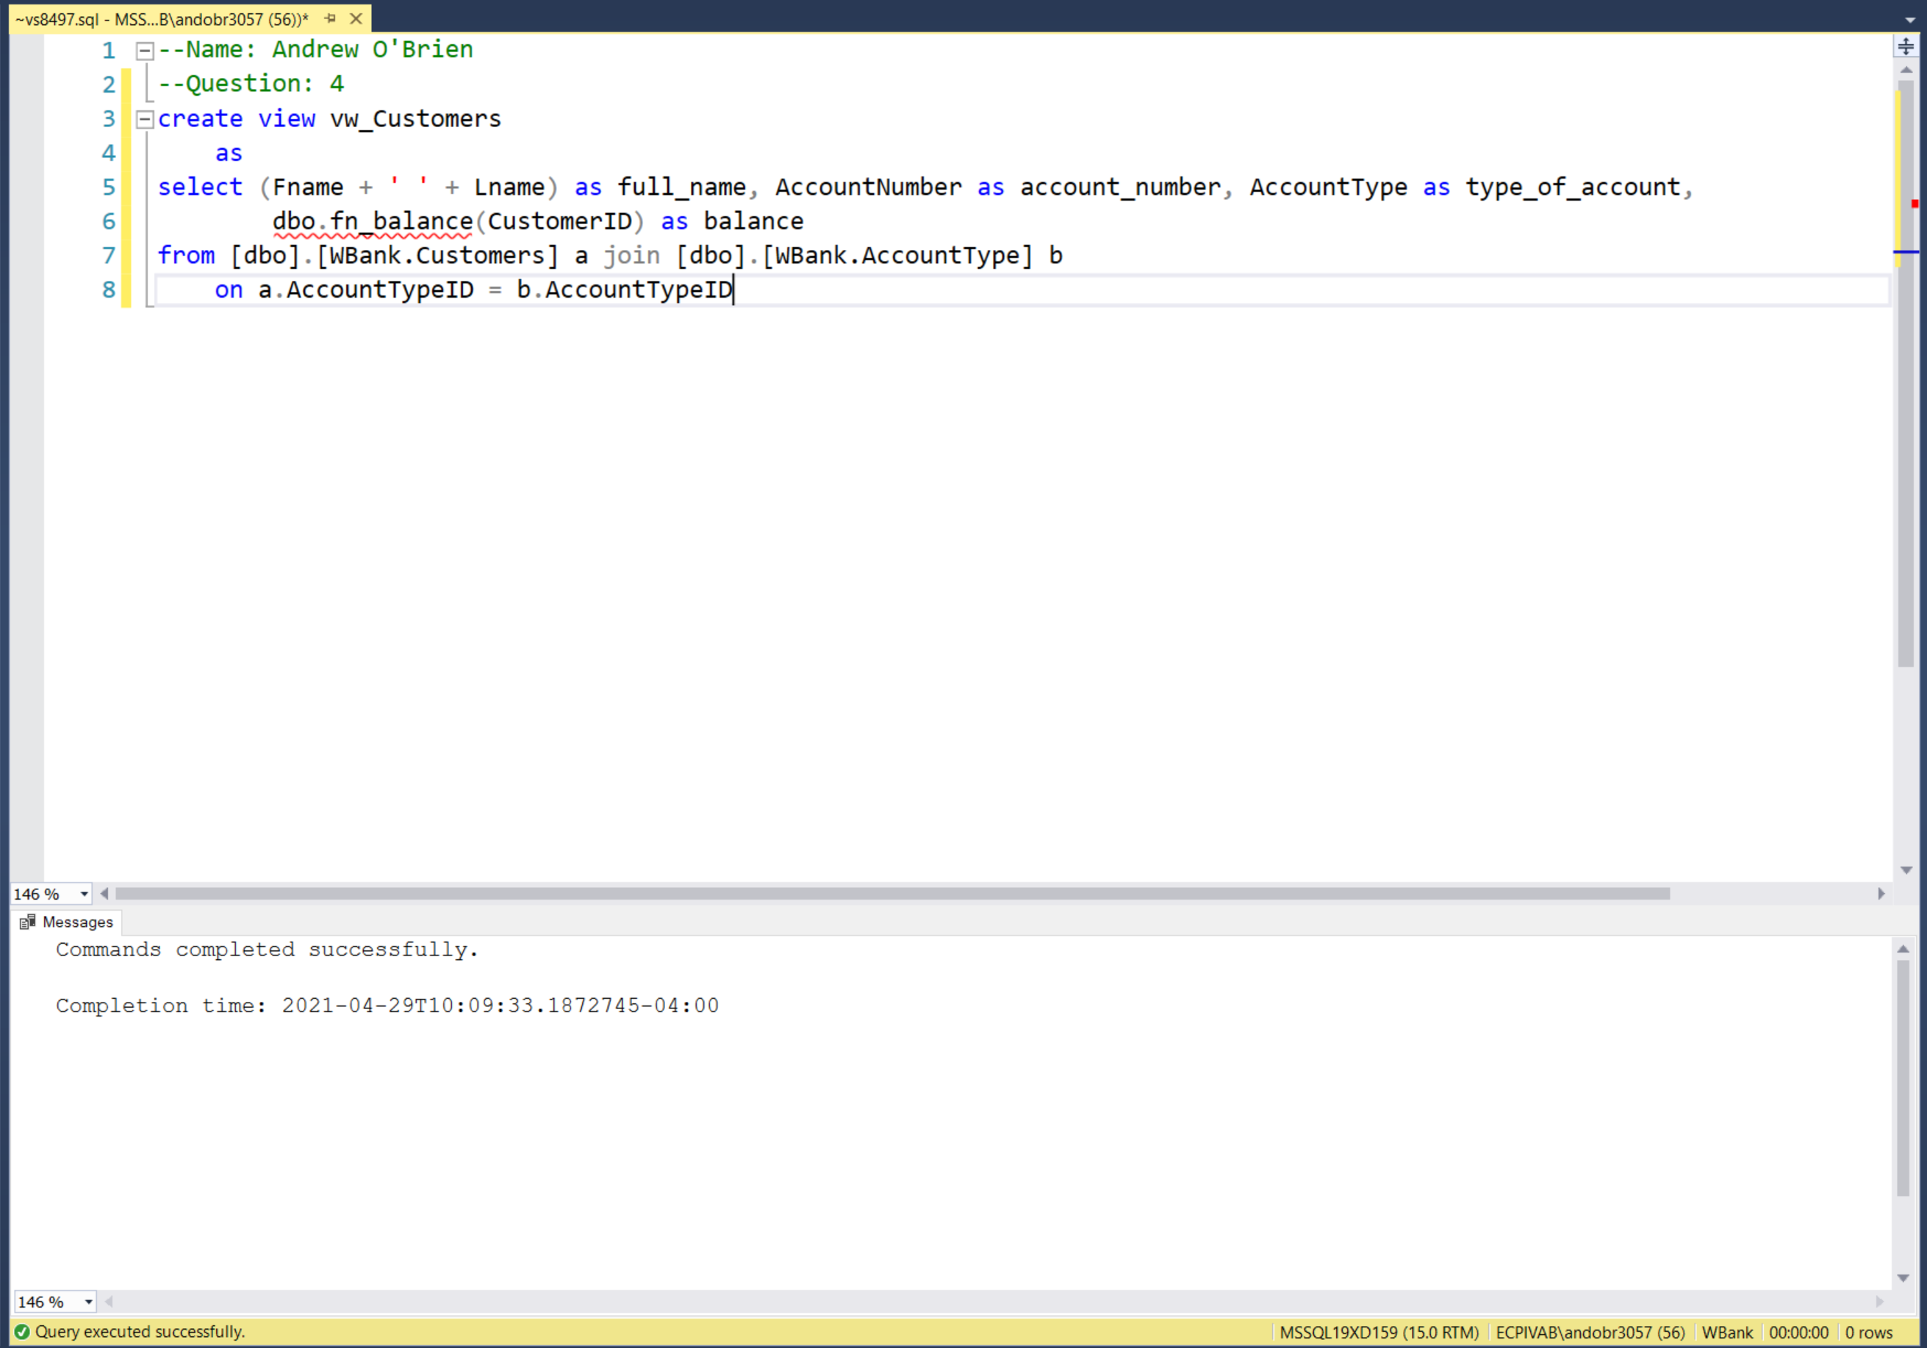

1. Create a stored procedure called sp_all_customers that returns a select statement based on all columns of your view created in question 4 above.

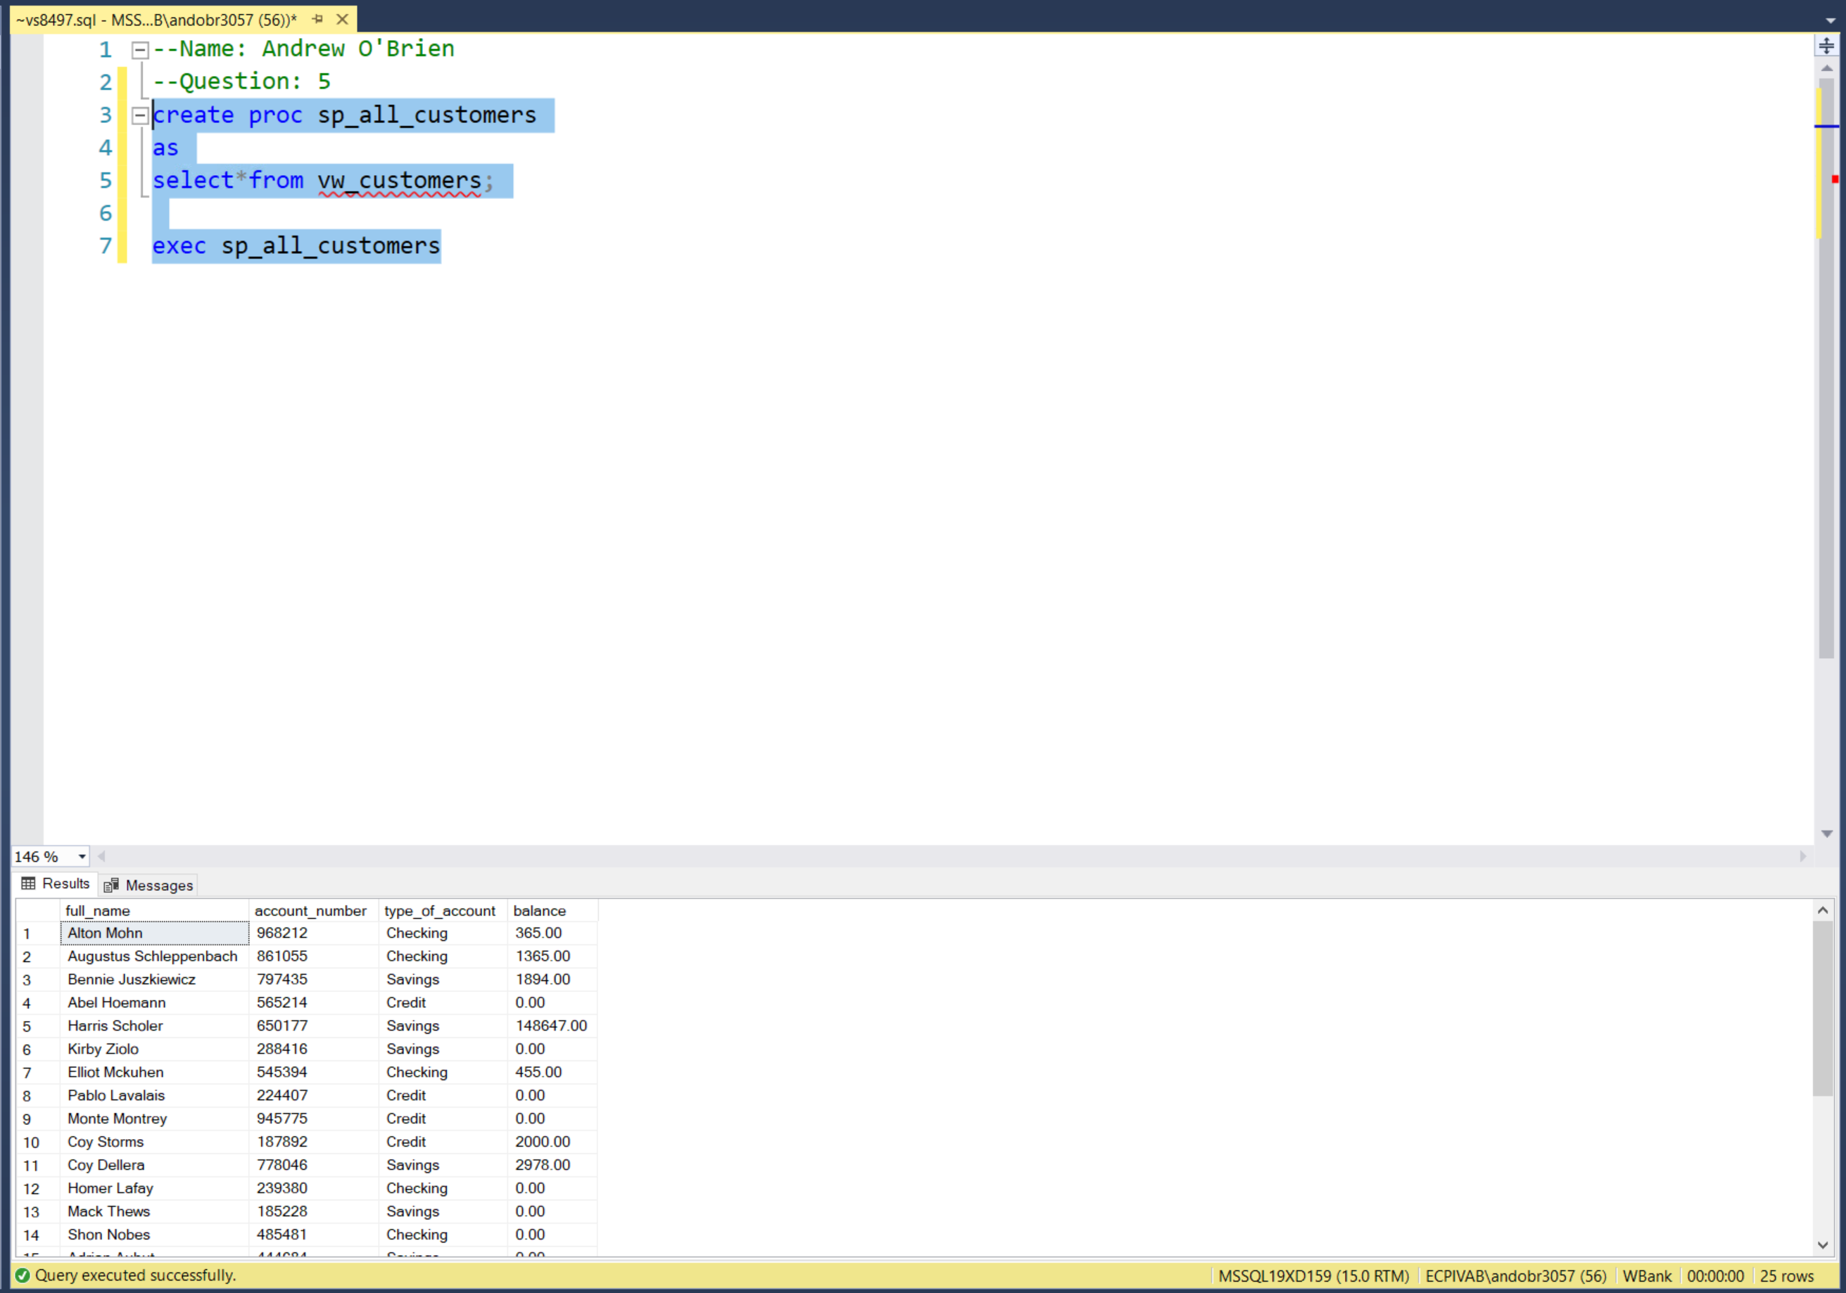

1. Create a stored procedure, called sp_customer, that takes in a CustomerID as a parameter, and then returns a select statement that shows the full name of the customer, the full name of the employee that does the transaction, the name/code of the branch where the transaction was done, the transaction type (Deposit, or Withdrawal), and the amount of the transaction.  The columns returned should be cust_full_name, emp_full_name, location, transaction_type, amount, customer_id

